Jathiya Hamidi
DATA 205
Professor Lori Perine
CRN 202630

Educational Attainment and Socioeconomic Inequality Across Pittsburgh Neighborhoods

Introduction

Data: This project used three neighborhood level datasets that were obtained from the Western Pennsylvania Regional Data Center (WPRDC) using American Community Survey (ACS) estimates. The datasets focused on educational attainment, household wage income participation, and poverty status across Pittsburg neighborhoods.

The Educational Attainment dataset included census bases estimates for residents aged 25 and older, also focusing on bachelor's degree attainment percentages across neighborhoods. The household wage income dataset has estimates of total households and the households reporting wage or salary income in the past 12 months. The poverty status dataset includes estimates of people living above and below the federal poverty line.

Neighborhood names were used as the shared identifier to merge the datasets into one file. Some of the variables and census column were excluded during the preprocessing because they were not relevant to the project;s research question. The final cleaned dataset included 91 Pittsburg neighborhoods and 9 analytical variables focused on education, wage income participation, and poverty concentration.

Goals: The goal of this project was to examine how educational attainment relates to household wage income participation and poverty across Pittsburgh neighborhoods. More specifically the project was focused on seeing if neighborhoods with higher bachelor's degree attainment showed stronger economic outcomes and lower poverty rates.

This project is important because educational opportunity and economic stability are often connected, so by analyzing neighborhood level socioeconomic patterns, the project helps reveal how opportunity and financial hardship may be unevenly distributed across urban communities. Understanding these patterns can provide information into broader socioeconomic conditions throughout Pittsburg.

Tools: There were many tools and methods used throughout the project for data cleaning, analysis, visualization, and statistical testing. Google colab and Jupyter Notebook were used as the main coding and analysis.

Python libraries like pandas and numpy were used for data cleaning and manipulation. Matplotlib and seaborn were used to create visualizations and explore data analysis graphs. Statsmodes and SciPy were used for regression analysis and ANOVA stats testing. Github was used to document files throughout the project.

Summary of Data Cleaning and Pre-Processing
The data cleaning and preprocessing stage focuses on preparing multiple neighborhood level census datasets for analysis. The raw datasets were first imported into python using pandas in google colab.

Before merging the datasets, neighborhood names and identifiers were standardized to ensure there was consistency across the files, I had to trim and format inconsistencies as well as fixing the neighborhood labels. Rows with incomplete or missing values were looked over and cleaned to improve the dataset accuracy.

After standardizing, the education attainment, household wage income participation and poverty datasets were merged together using neighborhood as the shared identifier. Additional persistence based analytic variables were then created to support the exploratory and statistical analysis.
The final cleaned analytic dataset had 91 Pittsburg neighborhoods and 9 variables related to education attainment, wage-income participation, and poverty concentration, and everything was documented in my Github repository.

Basic Descriptive Statistics
The final analytical dataset had 91 Pittsburg neighborhoods and 9 variables related to educational attainment, household wage income participation and poverty concentration. The most important variables analyzed in the project had bachelors degree attainment percentage, household wage income participation percentage and poverty percentage.

Descriptive analysis also showed variation across neighborhoods, some neighborhoods like Strip District and Allegheny West showed some of the highest levels of bachelor's degree attainment while neighborhoods like Bedford Dwellings and Northview Heights showed much lower educational attainment levels.

The dataset also showed differences in poverty concentration across neighborhoods, Northview Heights and Arlington Heights showed some of the highest diversity rates in the dataset. While neighborhoods with stronger educational attainment generally experience lower poverty concentrations.
Household wage income participation rates also varied across neighborhoods, even through neighborhoods with higher educational attainment showed stronger wage income participation. Exploratory visualizations and descriptive statistics suggested some relations between educational attainment, wage income participation, and poverty concentration throughout Pittsburgh neighborhoods.
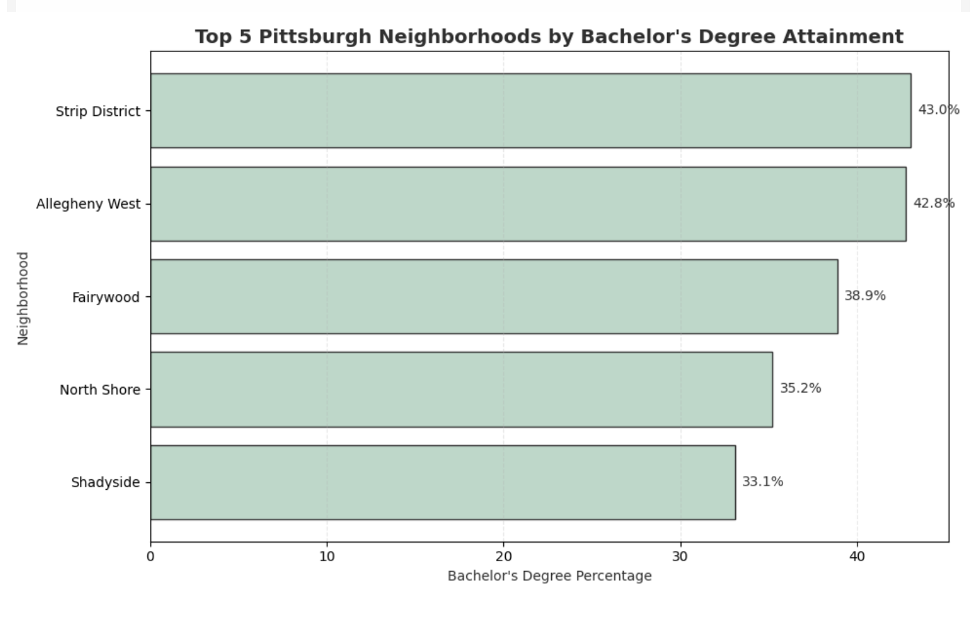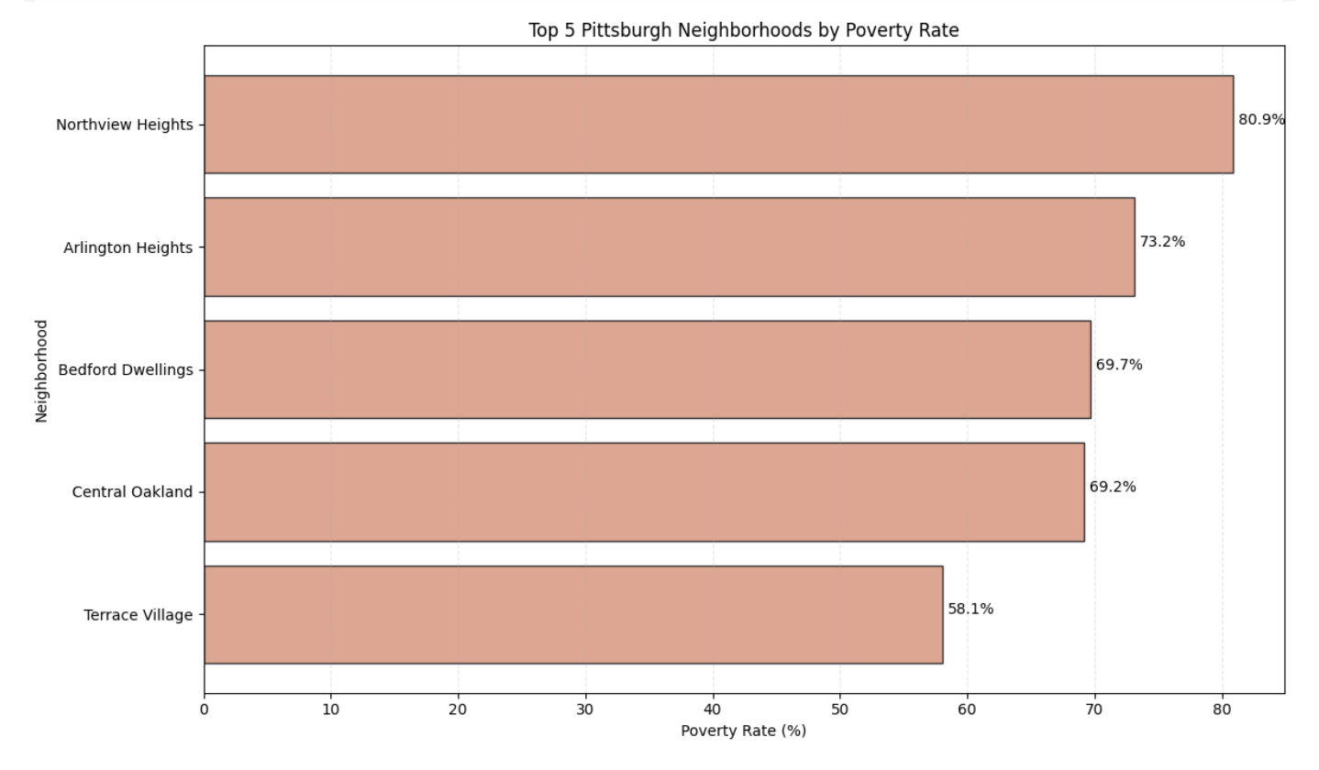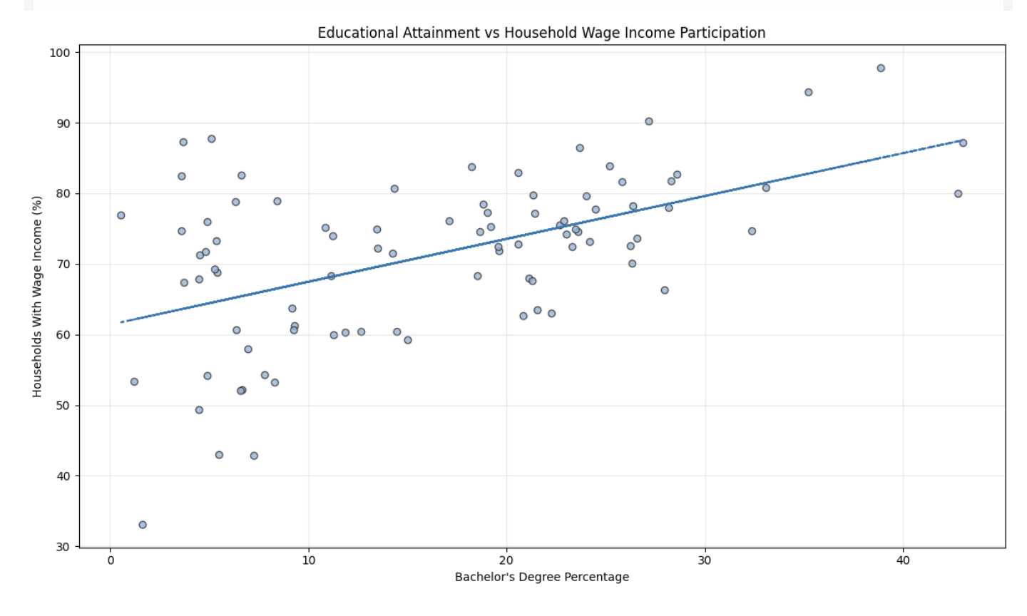
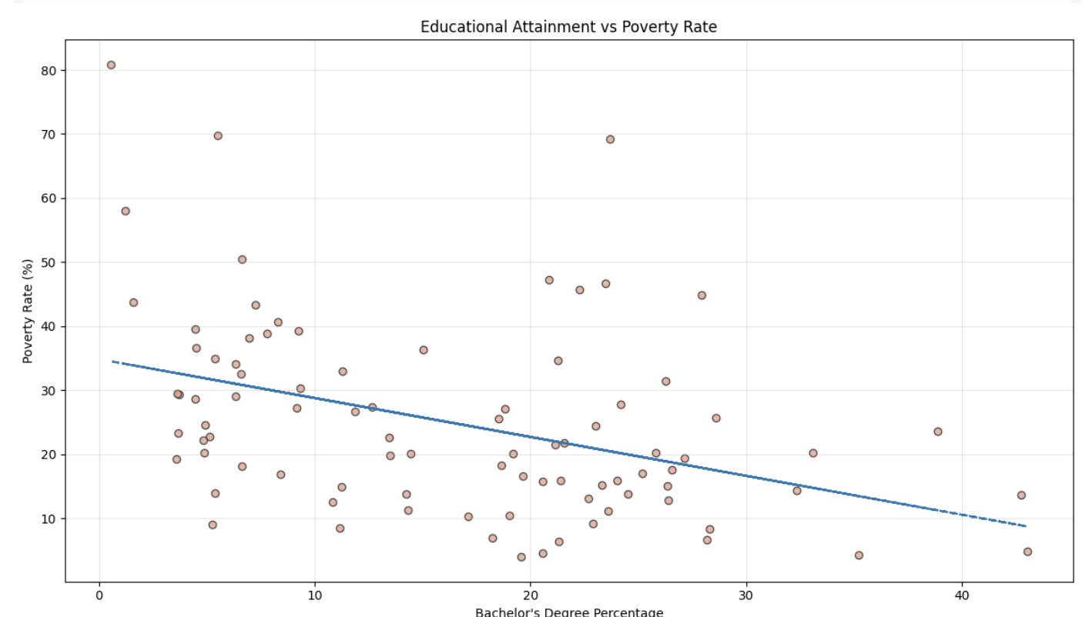
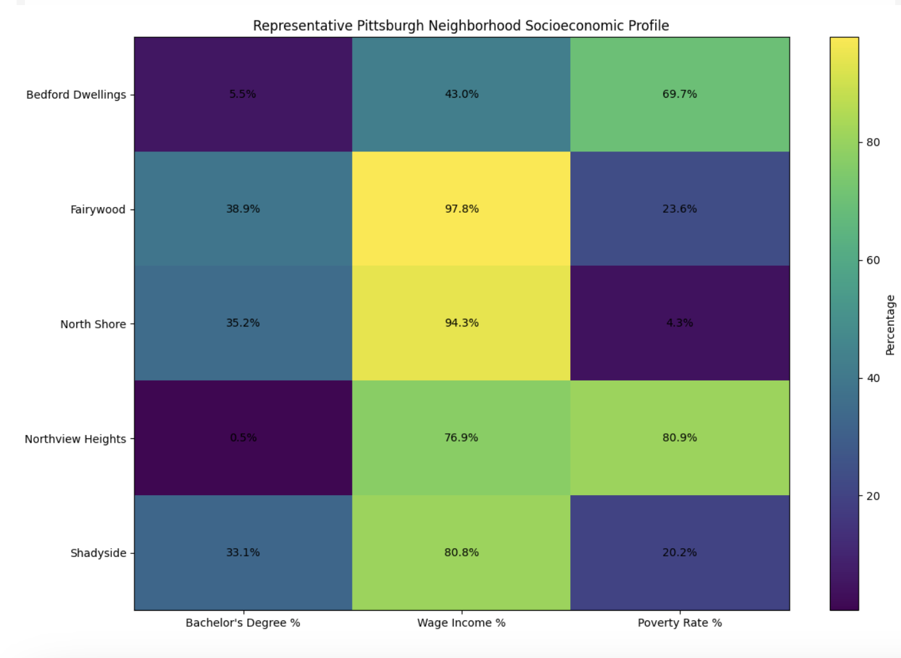

Description of Final Data Product
The final data product for this project has the cleaned analytical dataset, visualizations shown above, and statistical analysis outputs examining the relationships between educational attainment, wage income participation, and poverty concentration across Pittsburg neighborhoods.

I created many visualizations to identify neighborhood level socioeconomic patterns. Bar charts highlighted the differences in bachelor's degree attainment and poverty concentration across neighborhoods. Scatterplots showed a positive relationship between educational attainment and wage income participation. There is also a negative relationship between educational attainment and poverty rates.

A comparative heatmap was also used to examine multiple socioeconomic indicators across selected neighborhoods. Neighborhoods with higher educational attainment showed stronger wage income participation and lower poverty rates. While neighborhoods with lower educational attainment showed higher poverty concentration.

Regression analysis and ANOVA testing were conducted to evaluate if the relationships were statistically significant. The results also supported the trends identified during EDA and showed meaningful relationships between educational attainment and socioeconomic outcomes across Pittsburg neighborhoods.

Overall, the final data product provided insight into neighborhoods level inequality patterns and showed how education may be associated with broader economic conditions throughout the city.

References and Acknowledgements
Data Sources:
- Western Pennsylvania Regional Data Center (WPRDC)
- American Community Survey (ACS) 5-Year Estimates
Tools and Resources:
- Python
- Google Colab
- Jupyter Notebook
- pandas
- matplotlib
- seaborn
- statsmodels
- SciPy
- GitHub

Acknowledgements:
Professor Lori Perine for guidance and feedback throughout the DATA 205 capstone project process.

